# Training and test data set - Full

# Adam, 3HL, Relu, DLR:

Confusion Matrix:

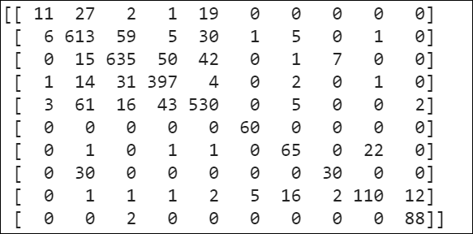

TP, TN, FP and FN

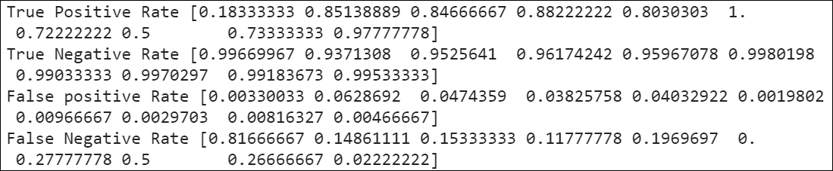

Classification report:

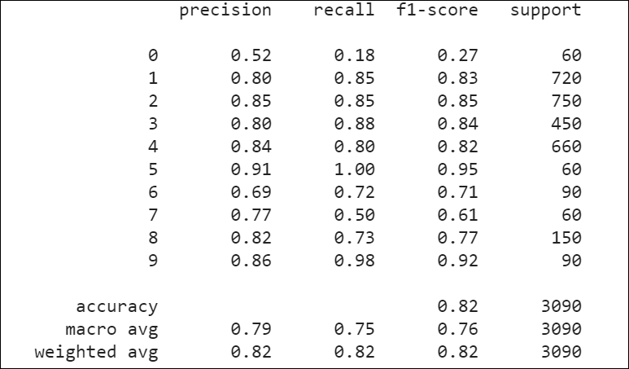

# Adam, 5HL, RELU, DLR:

Confusion Matrix

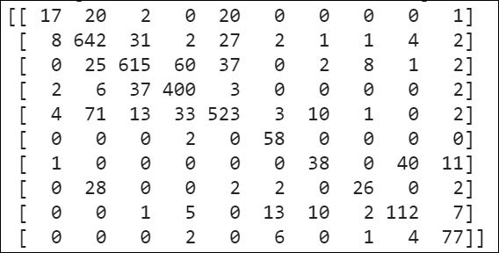

TP, TN, FP, FN:

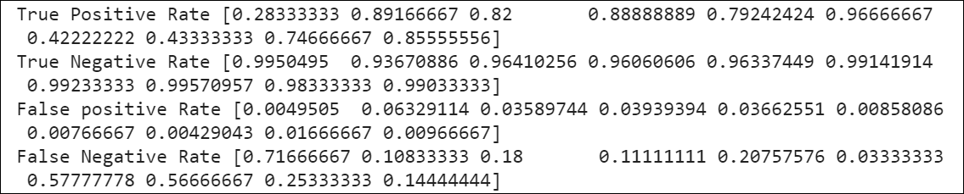

Classification report:

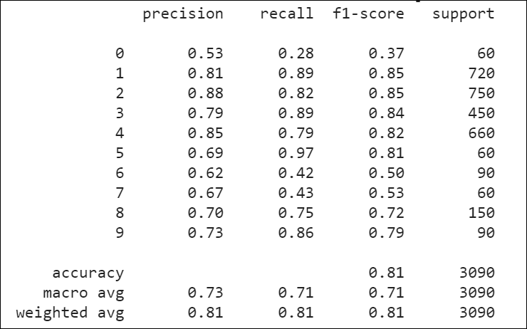

# Adam, 3HL, RELU, 0.1LR:

Confusion Matrix:  
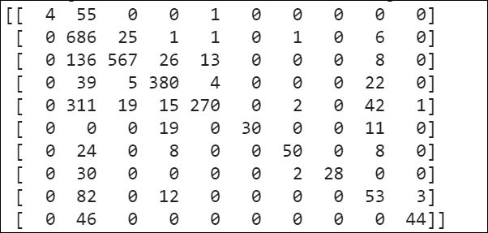

TN, TP, FN, FP

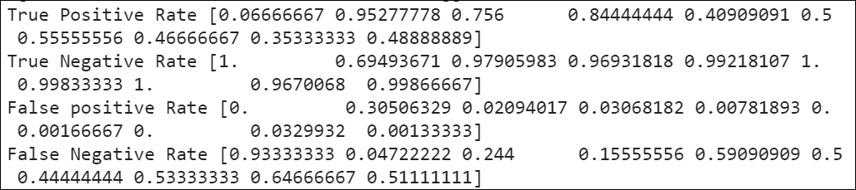

Classification Report:

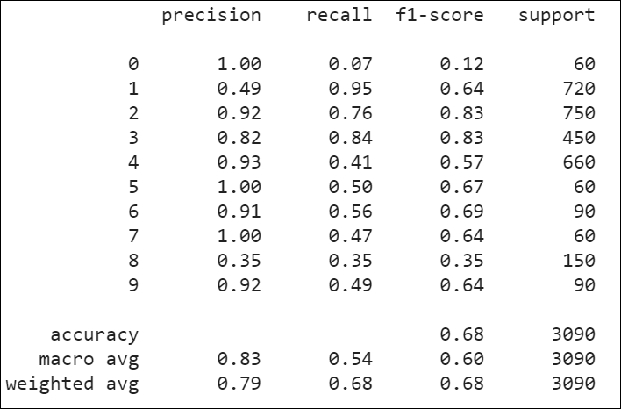

# Adam, 5HL, RELU, 0.1LR:

Confusion Matrix:

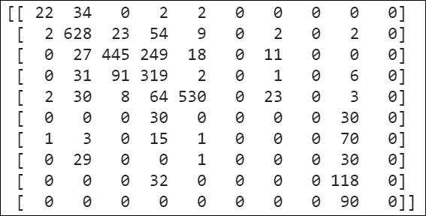

TP, TN, FP, FN

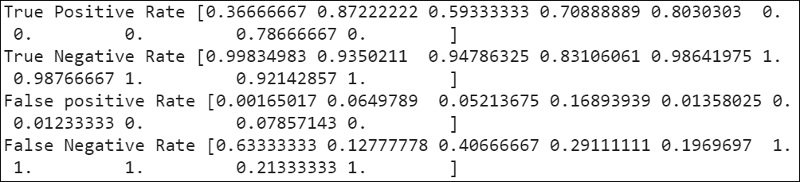

Classification Report:

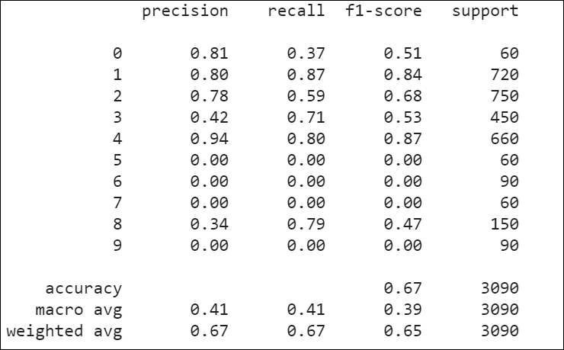

# Adam, 3HL, tanh, DLR:

Confusion Matrix:

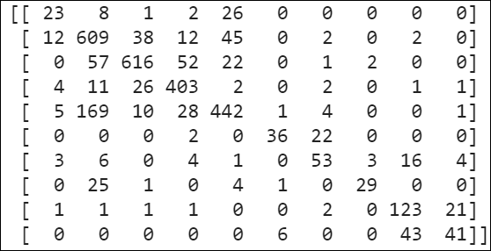

TN, TP, FN, FP:

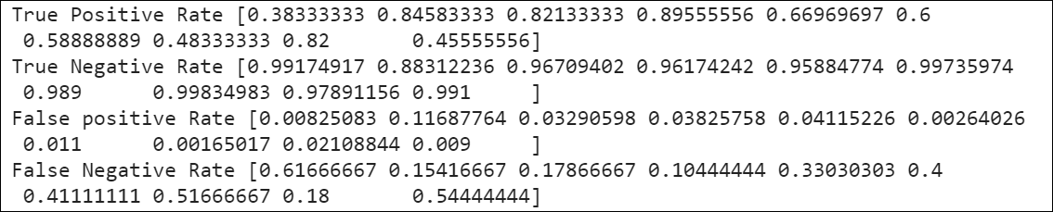

Classification Report:

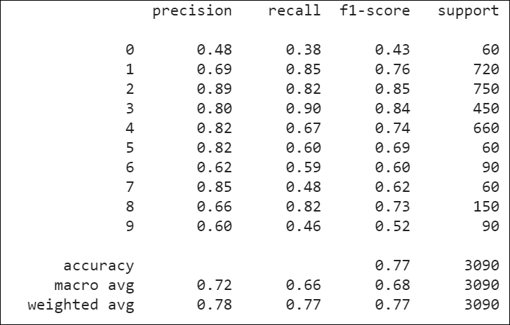

# Adam, 3HL, tanh, 0.1LR:

Confusion Matrix:

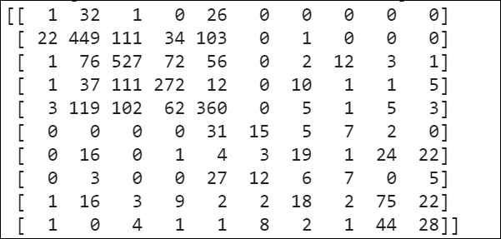

TP, TN, FP, FN:

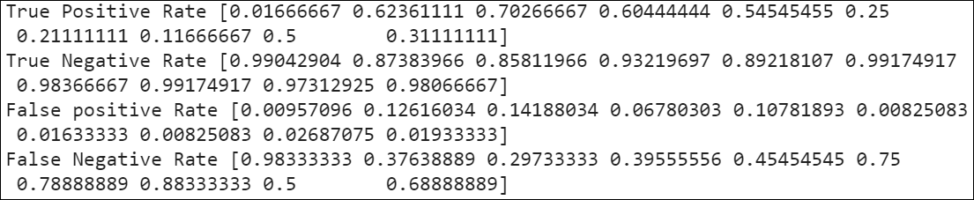

Classification Report:

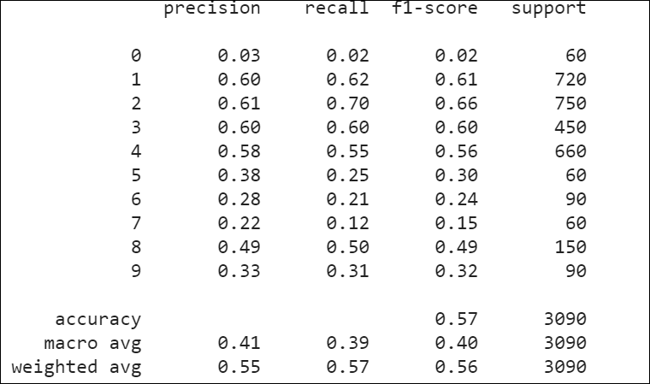

# Adam, 5HL, tanh, DLR:

Confusion Matrix:

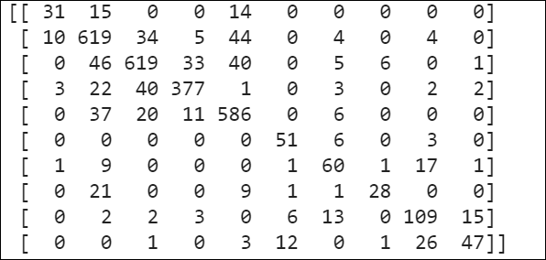

TP, TN, FP, FN:

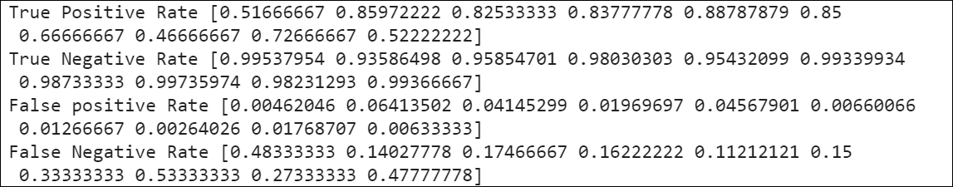

Classification report:

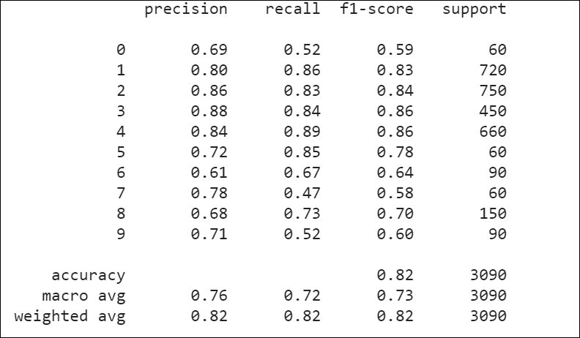

# 4000 Test instances

# Adam 3HL Relu DLR

Confusion matrix:

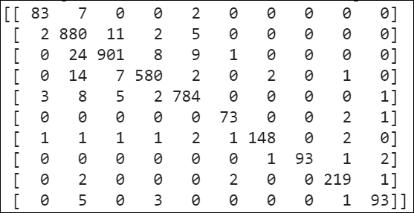

TP, TN, FP, FN

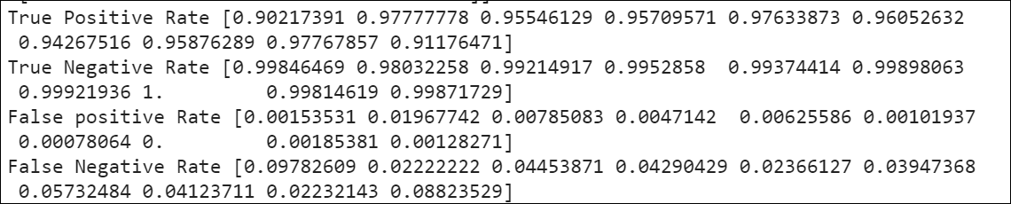

Classification Report:

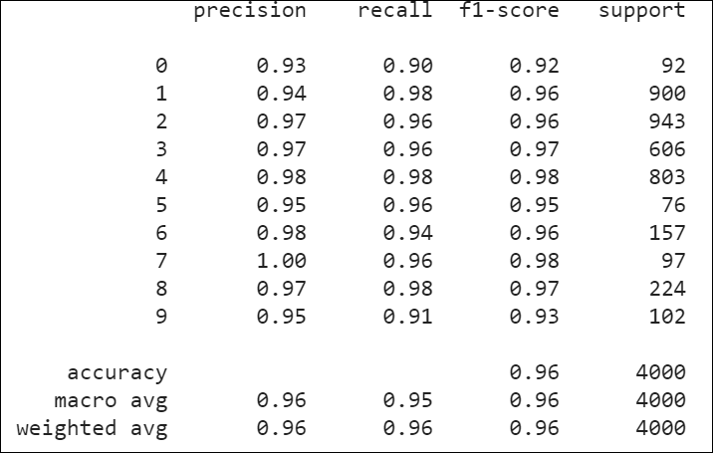

# Adam 3HL, Relu 0.1LR

Confusion matrix:

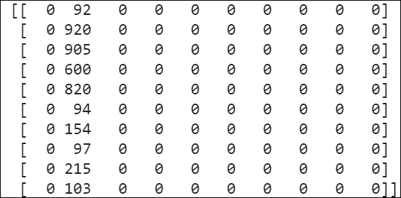

TN, TP, FP, FN

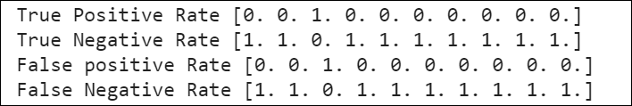

Classification Report:

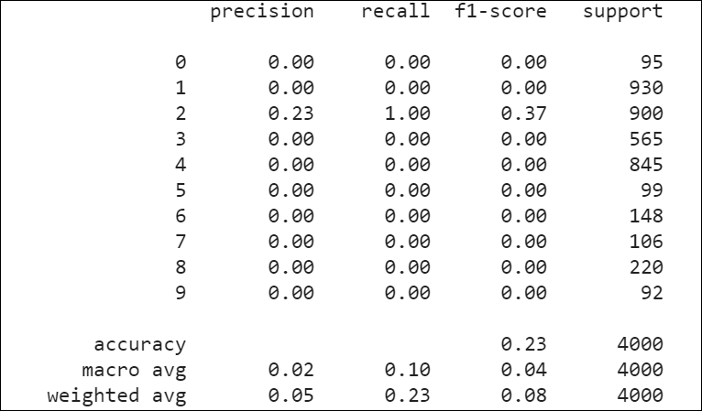

# Adam 5HL, Relu DLR

Confusion matrix:

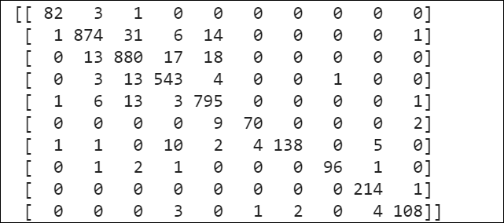

TN, TP, FP, FN:

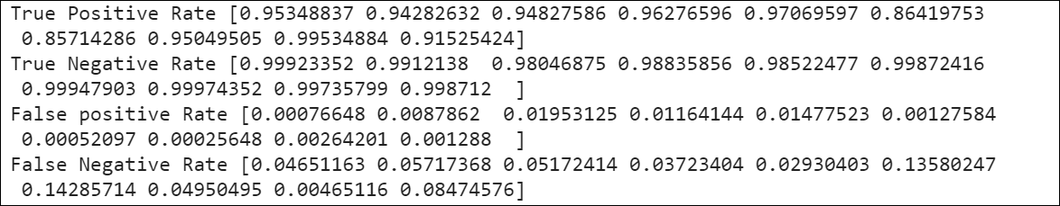

Classification Report:

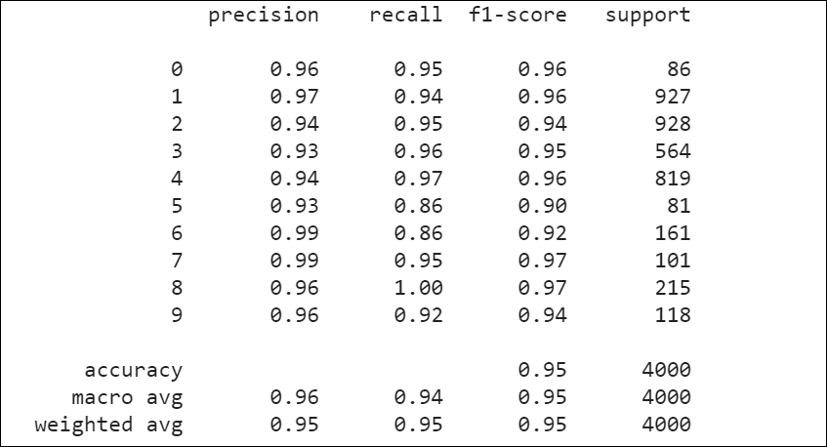

# Adam 5HL, Relu 0.1LR

Confusion Matrix:

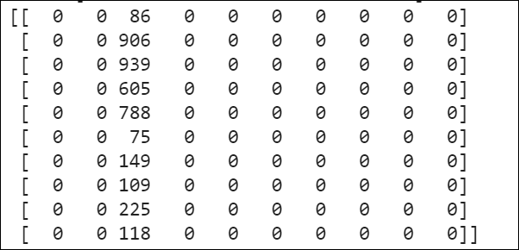

TP, TN, FP, FN:

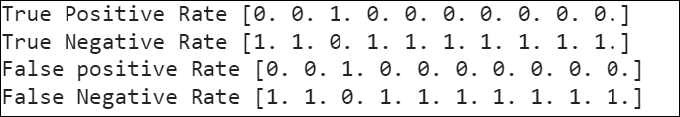

Classification Report:

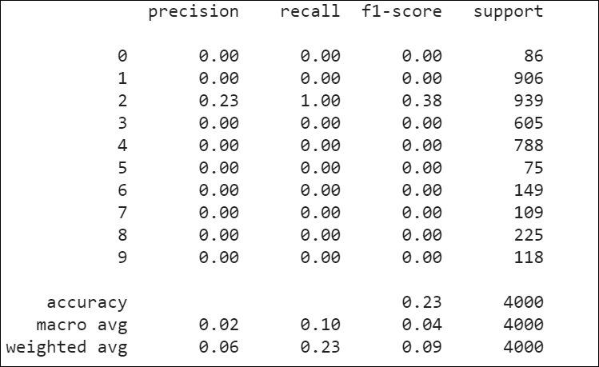

# Adam + 3HL + tanh + Default Learning Rate

Confusion Matrix:

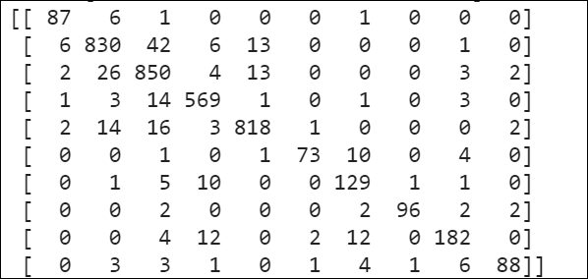

TP, TN, FP, FN:

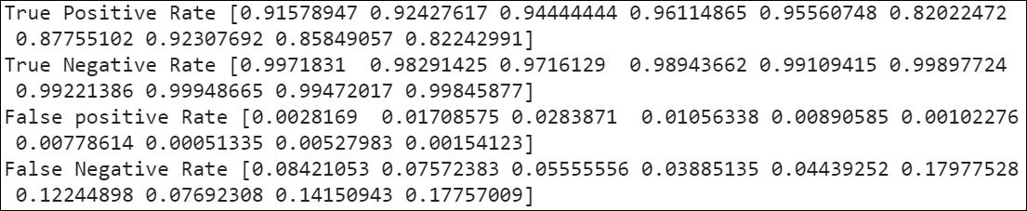

Classification report:

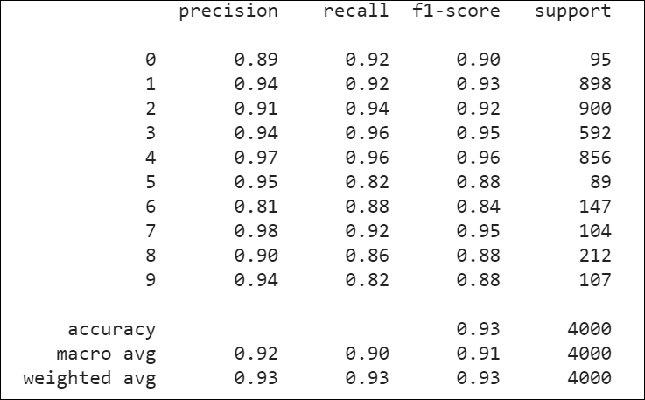

# Adam + 3HL + tanh + 0.1 Learning Rate

Confusion Matrix:

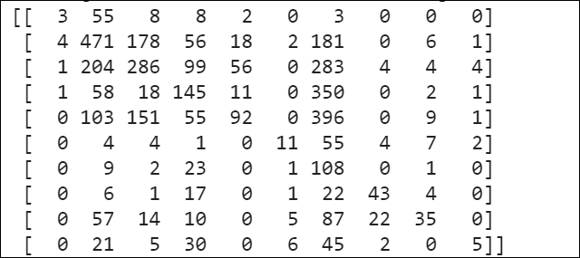

TP, TN,, FP, FN:

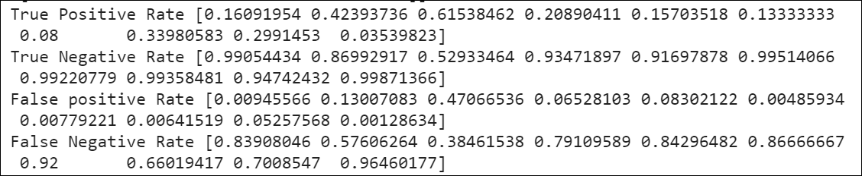

Classification Report:

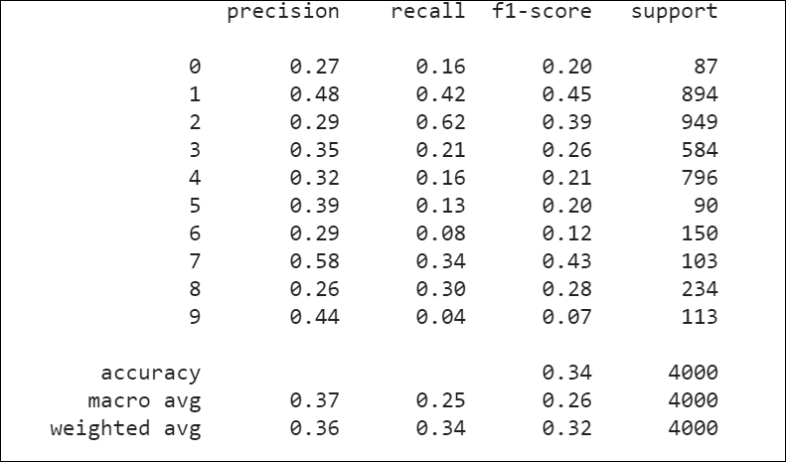

# Adam + 5HL + tanh + Default Learning Rate

Confusion Matrix:

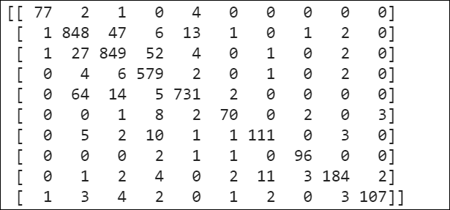

TP, TN, FP, FN:

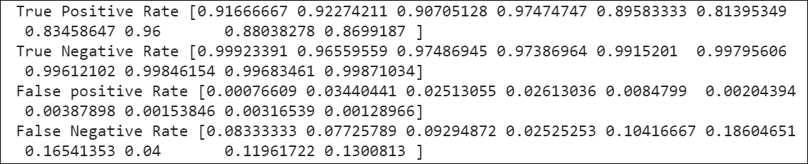

Classification report:

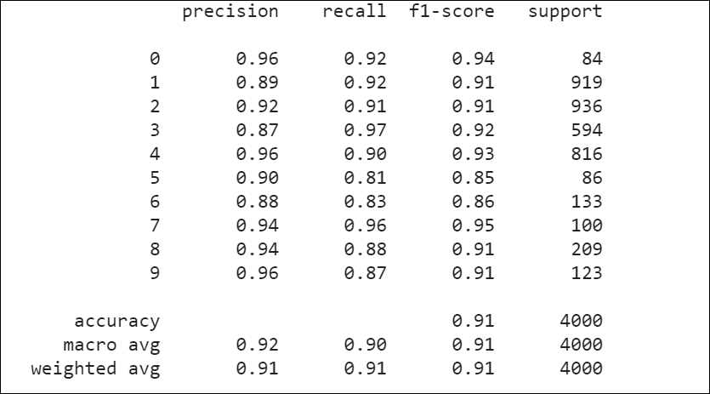

# Adam + 5HL + tanh + 0.1 Learning Rate

Confusion Matrix:

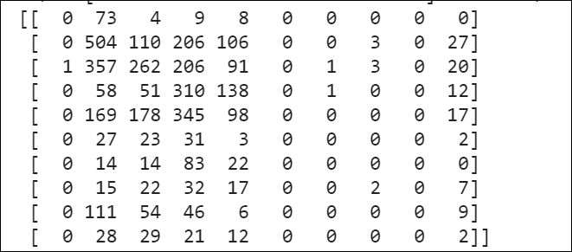

TP, TN, FP, FN:

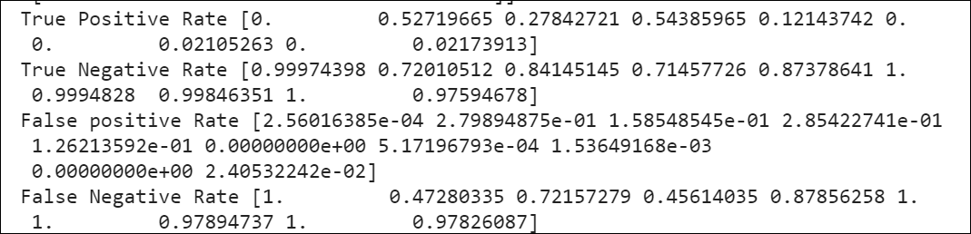

Classification Report:

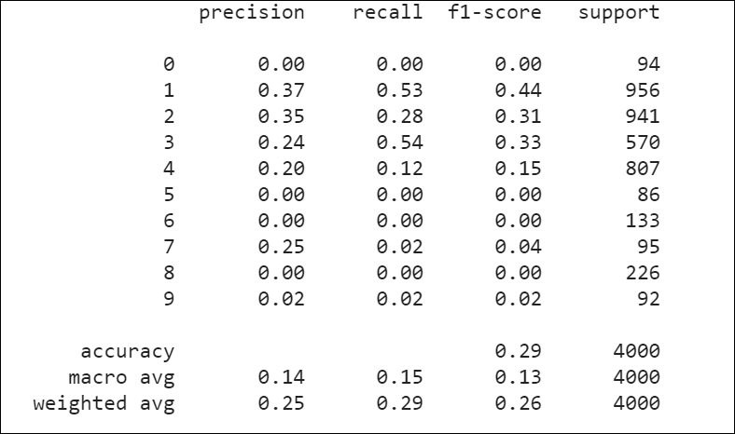

# 9000 Test Instances

# Adam + 3HL + Relu + Default Learning Rate

Confusion Matrix:

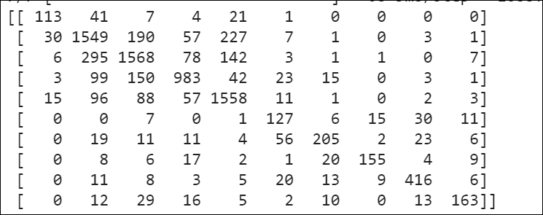

TP, TN, FP, FN:

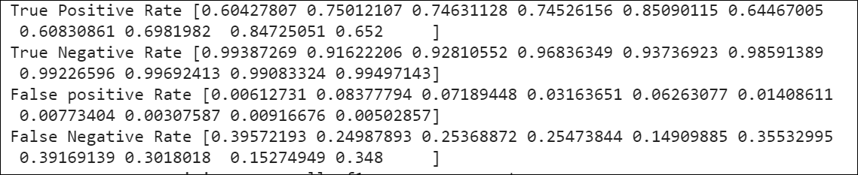

Classification Report:

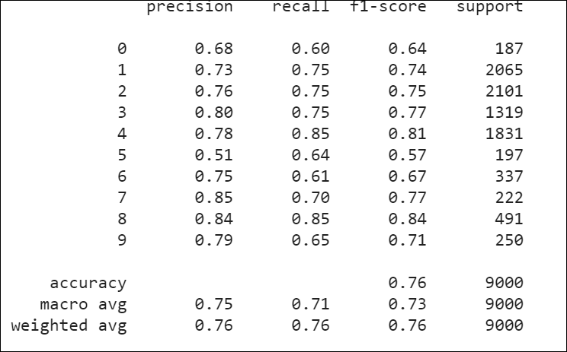

# Adam + 3HL + Relu + 0.1 Learning Rate

Confusion Matrix:

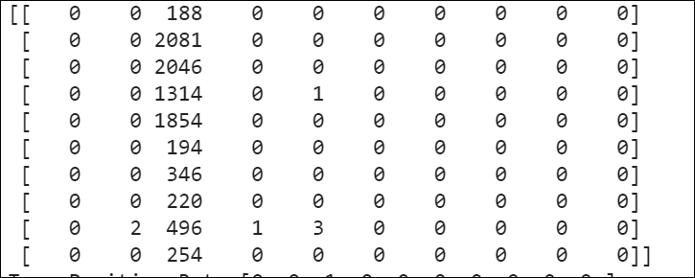

TP, TN, FP, FN

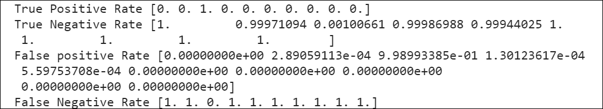

Classification Report:

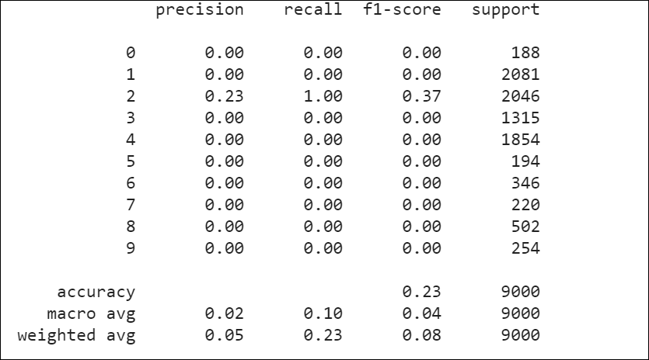

# Adam + 5HL + Relu + Default Learning Rate

Confusion Matrix:

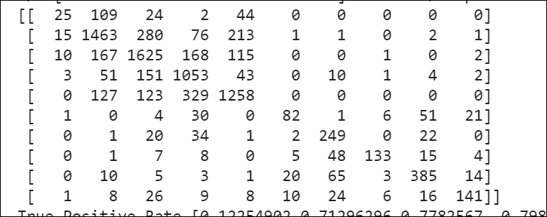

TP, TN, FP, FN:

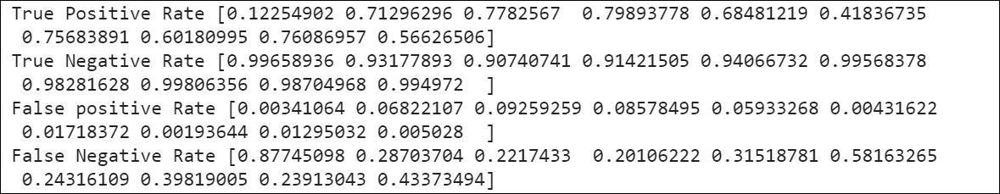

Classification Report:

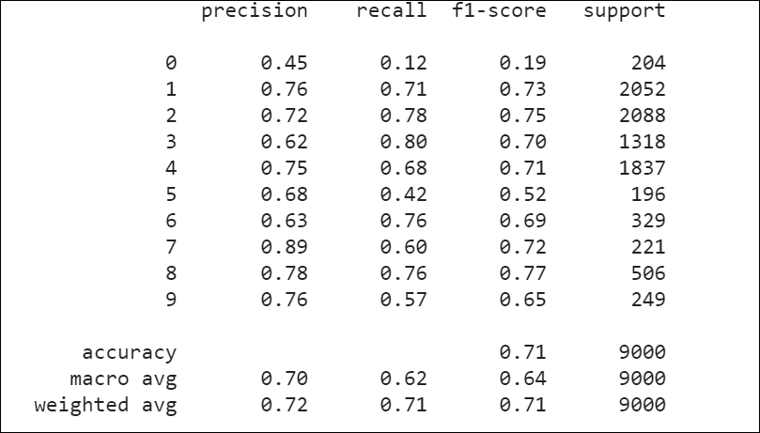

# Adam + 5HL + Relu + 0.1 Learning Rate

Confusion Rate

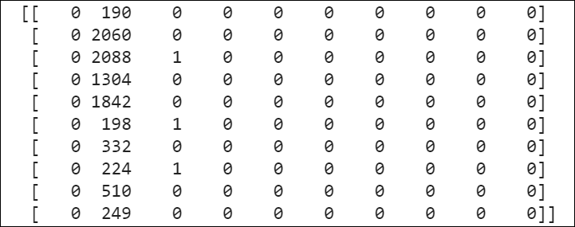

TP, TN, FP, FN:

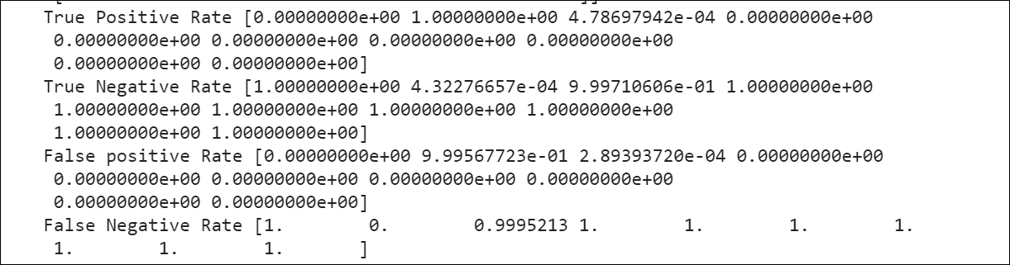

Classification Report:

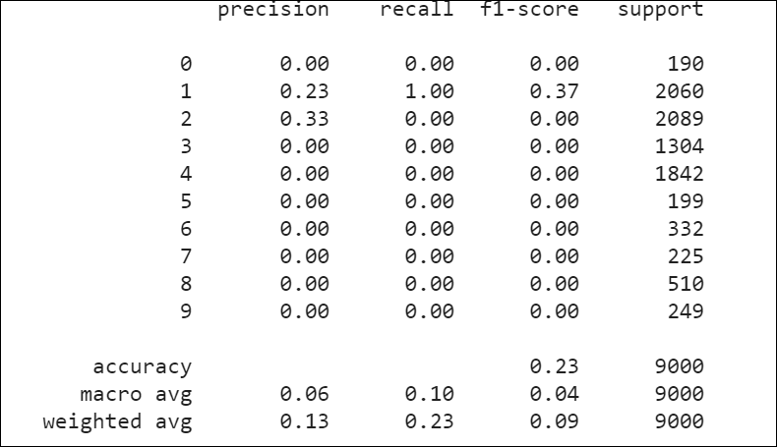

# Adam + 5HL + tanh + Default Learning Rate

Confusion Matrix:

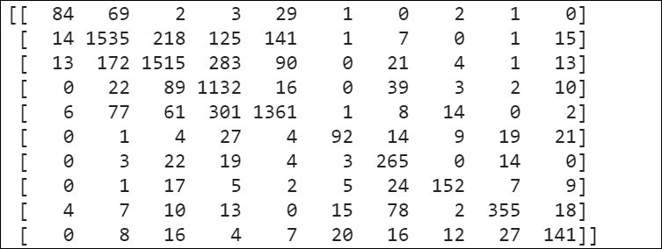

TP, TN, FP, FN:

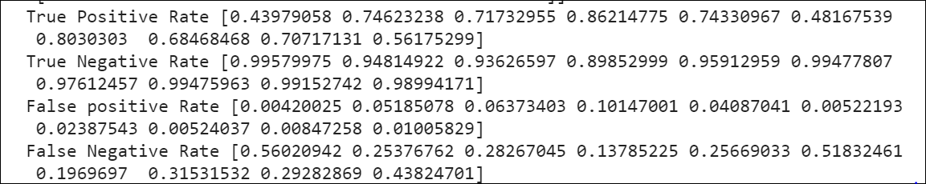

Classification Report:

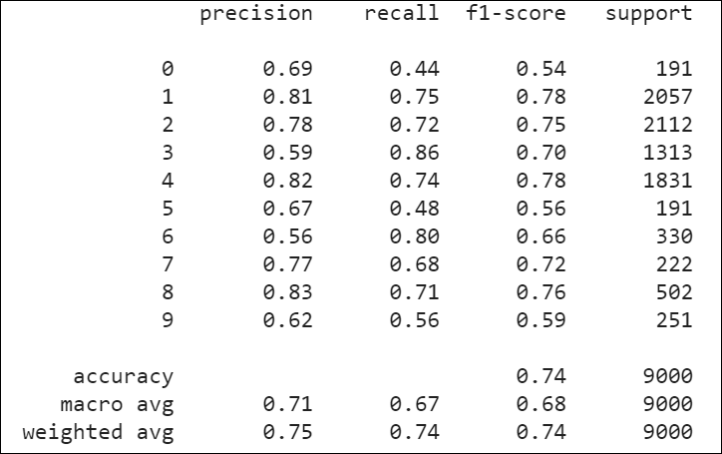

# Adam + 5HL + tanh + 0.1 Learning Rate

Confusion Matrix:

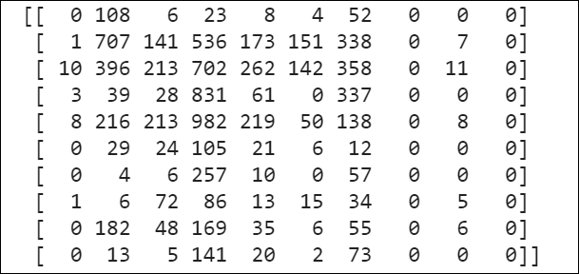

TP, TN, FP, FN

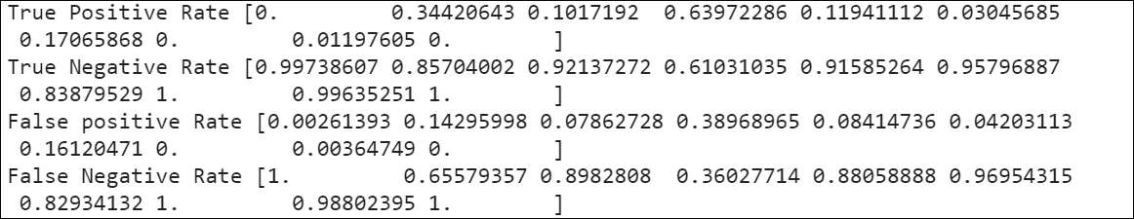

Classification Report:

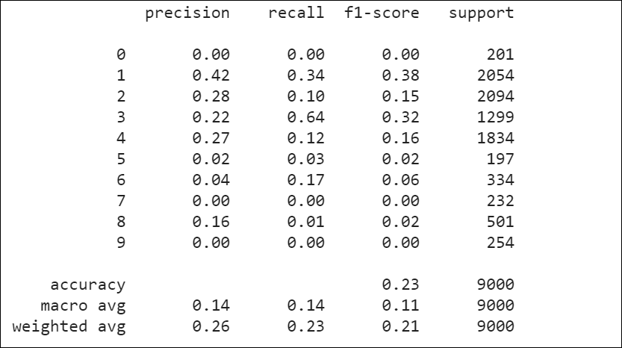

# Adam + 3HL + tanh + 0.1 Learning Rate

Confusion Matrix:

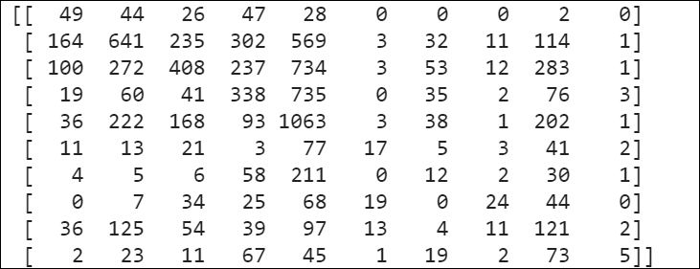

TP, TN, FP, FN

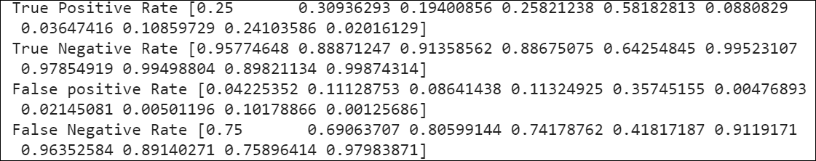

Classification Report:

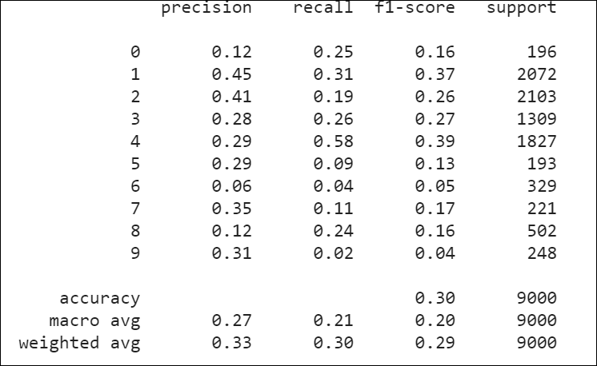

# Adam + 3HL + tanh + Default Learning Rate

Confusion matrix:

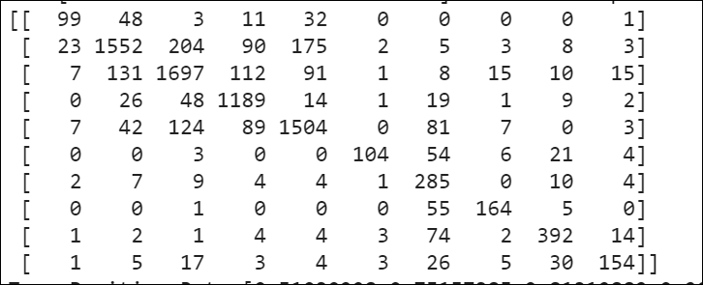

TP, TN, FP, FN:

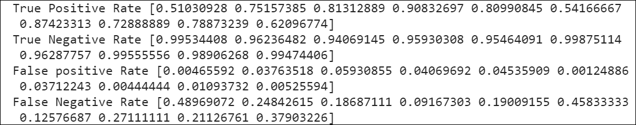

Classification Report:

